How Percoll is Used to Isolate PBMCs from Whole Blood
Luke Doiron on Apr 7, 2015 10:08:00 AM
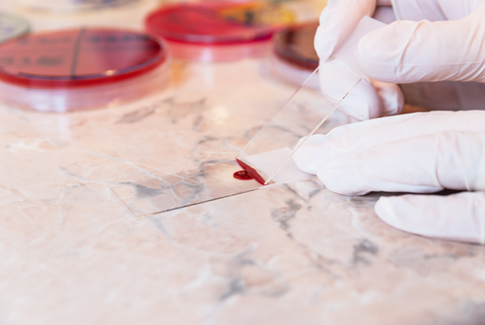
The peripheral blood mononuclear cell (PBMC) is a most versatile biospecimen, containing a variety of cells that play a critical role in the healthy functioning of the body's immune system. PBMCs can be readily separated from whole blood specimens, and provide a reliable tool for studying a plethora of pathologic processes including infectious diseases, autoimmune disorders and cancer. In addition, studies show that PBMCs may be a useful source for regenerative therapies due to their ability to differentiate into multiple cell types.
PBMCs are defined as blood cells that have a prominent round nucleus, with the most numerous being lymphocytes and monocytes. Lymphocytes are comprised of T cells, B cells and NK (natural killer) cells.
To obtain PBMCs, they must first be isolated from whole blood samples. One of the most common and reliable methods for isolating PBMCs uses a silica colloid known as Percoll™. First introduced in 1977, this density-gradient medium is utilized for many studies because it:
- is non-toxic,
- has low osmolarity and viscosity,
- doesn't penetrate biological membranes,
- will not affect assay procedures,
- is easily removed from purified isolates, and
- can form continuous and discontinuous gradients.
Here is one commonly recommended protocol for the separation of human blood cells in a gradient of Percoll.
- Prepare an osmotically-adjusted Stock Isotonic Percoll (SIP) solution, which is isotonic with cell preparation Dilute to desired starting densities with physiological saline solution. Note: Solutions of SIP are diluted to lower densities simply by adding 0.15 M NaCl (or normal strength cell culture medium) for cell work, or with 0.25 M sucrose when working with subcellular particles or viruses.
- Then, Either (Method 1) perform the gradient by layering, gradient former or by centrifugation (e.g. 30 000 × g for 15 to 45 min. in an anglehead rotor). Performing a gradient by centrifugation can be a convenient alternative to using a gradient maker or pump. Percoll will sediment when subjected to significant g-forces (> 10 000 × g).; OR (Method 2) mix cell preparation with diluted iso-osmotic Percoll to form a homogenous suspension.
- Use Density Marker Beads to monitor the gradient.
- (Method 1): Layer the cell suspension on preformed gradient and centrifuge (e.g. 400 to 800 × g for 10 to 20 min. in swinging bucket or angle-head rotor). (Method 2) Centrifuge (e.g. 30 000 × g for 15 to 45 min. in an anglehead rotor).
- Fractionate gradient by upward displacement. This is a simple technique for collecting the fractions from the top of the tube by displacement with a dense medium such as undiluted Percoll, or a 60-65% sucrose solution. Once this dense material is pumped to the tube bottom, fractions can be taken off the top.
- Use cell fraction directly. Remove Percoll from cells by washing, if desired. However, suppliers of Percoll note that since it is nontoxic to biological materials and doesn't adhere to membranes, it is usually unnecessary to remove Percoll from the purified preparation.

